**Given ERD Diagram:**



**ERD Rule Violations:**

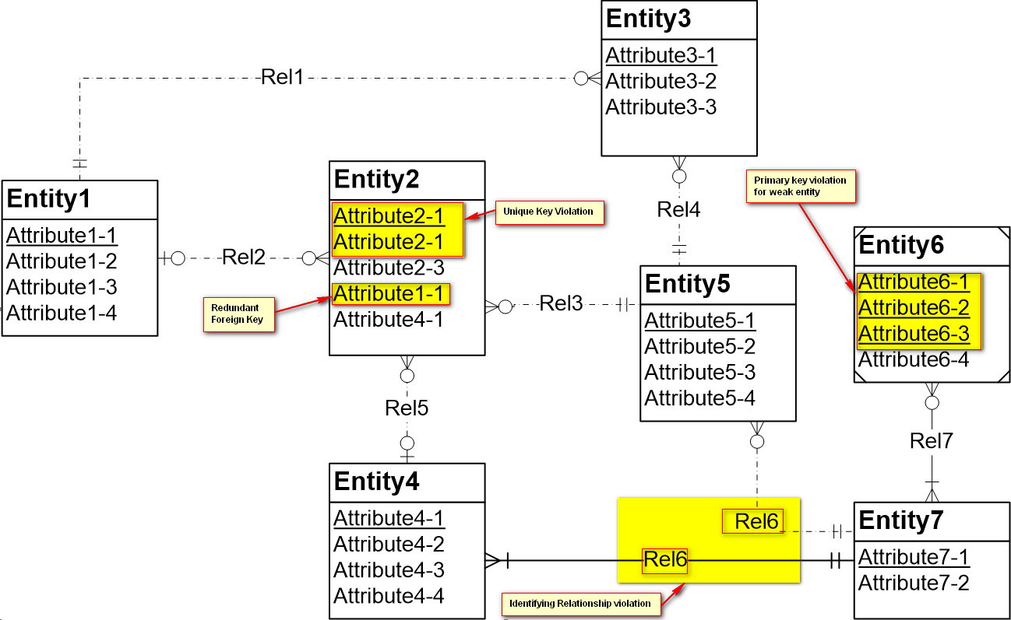

1. Weak Entity ‘Entity 6’ is assigned with 3 primary keys.
2. ‘Attribute 1-1’ in ‘Entity2’ is redundant foreign key.
3. Unique key violation for Attribute2-1 in Entity2
4. Identifying relationship violation for ‘Rel6’